MOBILE ANALYSIS SQL QUEREIS

**KPI**

**1.Check Mobile features and price list.**

select Phone_name, Price

from mobile;

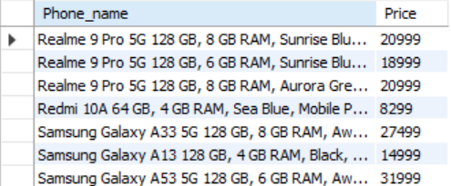

**2.Find out the price of 5 most expensive phones.**

select * from mobile

order by price desc

limit 5;

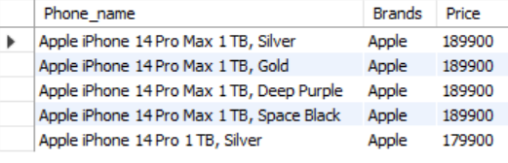

3. **Find out the price of 5 most cheapest phones.**

select * from mobile

order by price asc

limit 5;

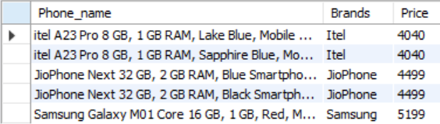

4. **List of top 5 Samsung phones with price and all features.**

select * from mobile where Brands = 'Samsung'

order by price desc

limit 5;

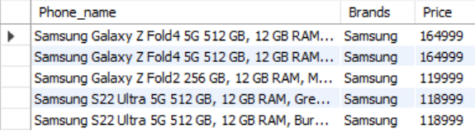

**5.Must have android phones list then top 5 High price android phones.**

select * from mobile

where operating_system_type = "Android"

order by price desc

limit 5;

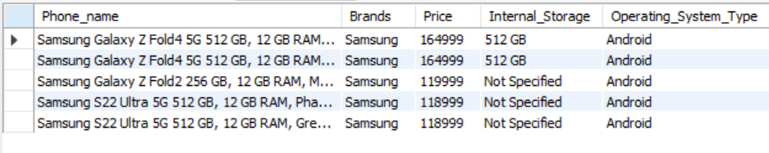

**6.Must have android phones list then top 5 Lower price android phones.**

select * from mobile

where operating_system_type = "Android"

order by price asc

limit 5;

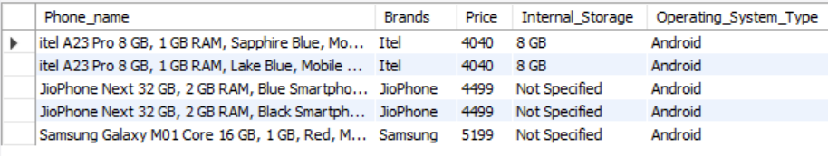

**7.Must have IOS phones list then top 5 High price IOS phones.**

select * from mobile

where operating_system_type = "iOS"

order by price desc

limit 5;

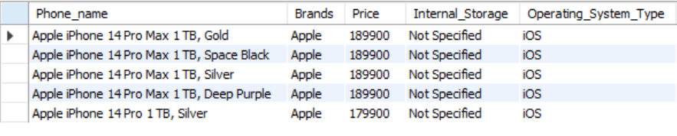

8. **Must have IOS phone list then top 5 Lower price IOS phones.**

select * from mobile

where operating_system_type = "iOS"

order by price asc

limit 5;

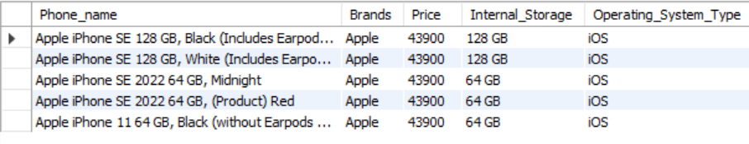

**9.Write a query which phone 5g support and also top 5 phone with 5h support.**

select * from mobile

where 5G_Availability = "yes"

order by price desc

limit 5;

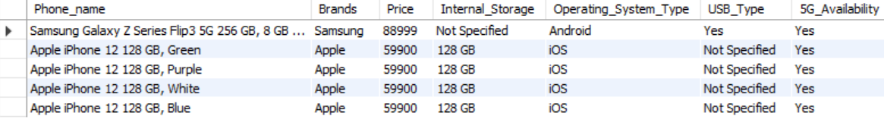

**10.Total price of all mobile is to be found with brand name.**

select Brands, sum(price)

from mobile

group by Brands;

